***Software Engineering******Lecture # 3***

***Objectives:***

* To introduce Software Development Life Cycle
* To discuss various phases of Software Development Life Cycle

***Software Development Life Cycle:***

* Software Development Life Cycle, SDLC for short, is a well-defined, structured sequence of stages in software engineering to develop the intended software product.
* SDLC provides a series of steps to be followed to design and develop a software product efficiently.

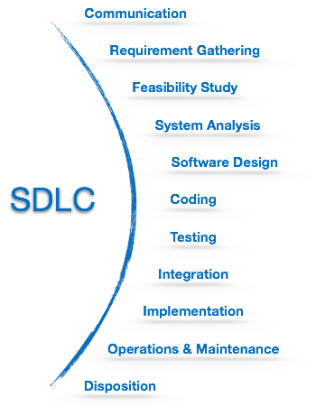

***Communication:***

* This is the first step where the user initiates the request for a desired software product.
* Involves communication among the customer and other stake holders; encompasses requirements gathering.
* The user contacts the service provider and tries to negotiate the terms, submits the request to the service providing organization in writing.

***Modelling: Software Requirements Analysis:***

* Helps software engineers to better understand the problem they will work to solve
* Encompasses the set of tasks that lead to an understanding of what the business impact of the software will be, what the customer wants, and how end-users will interact with the software
* Uses a combination of text and diagrams to depict requirements for data, function, and behaviour
  + Provides a relatively easy way to understand and review requirements for correctness, completeness and consistency

***Requirement Gathering:***

* The team holds discussions with various stakeholders from problem domain and tries to bring out as much information as possible on their requirements.
* The requirements are contemplated and segregated into user requirements, system requirements and functional requirements.
* studying the existing or obsolete system and software,
* conducting interviews of users and developers,
* referring to the database
* collecting answers from the questionnaires.

***Feasibility Study:***

* After requirement gathering, the team comes up with a rough plan of software process.
* At this step the team analyzes if a software can be designed to fulfill all requirements of the user, and if there is any possibility of software being no more useful.
* It is also analyzed if the project is financially, practically, and technologically feasible for the organization to take up.
* There are many algorithms available, which help the developers to conclude the feasibility of a software project.

***There are mainly five types of feasibilities checks:***

1. ***Economic:***

Can we complete the project within the budget or not?

1. ***Legal****:*

Can we handle this project as cyber law and other regulatory framework/compliances.

1. ***Operation feasibility****:*

Can we create operations which is expected by the client?

1. ***Technical****:*

Need to check whether the current computer system support the software

1. ***Schedule:***

Decide that the project can be completed within the given schedule or not.

***Planning:***

Establishes a plan for software engineering work; addresses technical tasks, resources, work products, and work schedule

***System Analysis:***

* At this step the developers decide a roadmap of their plan and try to bring up the best software model suitable for the project.
* System analysis includes understanding of software product limitations, learning system related problems or changes to be done in existing systems beforehand, identifying and addressing the impact of project on organization and personnel etc.
* The project team analyzes the scope of the project and plans the schedule and resources accordingly.